**What is Cloud Computing**

* Cloud computing is the on-demand availability of computer system resources, especially data storage and computing power, without direct active management by the user. The term is generally used to describe data centres available to many users over the Internet.
* Cloud computing is an internet-based computing service in which large groups of remote servers are networked to allow centralized data storage, and online access to computer services or resources.

**Cloud computing is a model that enables the following features.**

• Users can provision and release resources on-demand.

• Resources can be scaled up or down automatically, depending on the load.

• Resources are accessible over a network with proper security.

• Cloud service providers can enable a pay-as-you-go model, where customers are charged based on the type of resources and per usage.

**AdvantagesofCloudComputing**

**Cost-Efficient:**

Building our own servers and tools is time-consuming as well as expensive as we need to order, pay for, install, and configure expensive hardware, long before we need it. However, using cloud computing, we only pay for the amount we use and when we use the computing resources. In this manner, cloud computing is cost efficient.

**Reliability:**

A cloud computing platform provides much more managed, reliable and consistent service than an in-house IT infrastructure. It guarantees 24x7 and 365 days of service. If any of the servers fails, then hosted applications and services can easily be transited to any of the available servers.

**Unlimited Storage**:

Cloud computing provides almost unlimited storage capacity, i.e., we need not worry about running out of storage space or increasing our current storage space availability. We can access as much or as little as we need.

**Backup & Recovery:** Storing data in the cloud, backing it up and restoring the same is relatively easier than storing it on a physical device. The cloud service providers also have enough technology to recover our data, so there is the convenience of recovering our data anytime.

**Easy Access to Information:** Once you register yourself in cloud, you can access your account from anywhere in the world provided there is internet connection at that point. There are various storage and security facilities that vary with the account type chosen.

**Types of Clouds**

There are three types of clouds − **Public**, **Private**, and **Hybrid cloud**.

**Public Cloud:**

In public cloud, the third-party service providers make resources and services available to their customers via Internet. Customer’s data and related security is with the service providers’ owned infrastructure.

**Private Cloud:**

A private cloud also provides almost similar features as public cloud, but the data and services are managed by the organization or by the third party only for the customer’s organization. In this type of cloud, major control is over the infrastructure so security related issues are minimized.

**Hybrid Cloud:**

A hybrid cloud is the combination of both private and public cloud. The decision to run on private or public cloud usually depends on various parameters like sensitivity of data and applications, industry certifications and required standards, regulations, etc.

**Cloud Service Models:**

3 building block of cloud computing are

•Iaas

•Paas

•Saas

**1. IAAS:**

Infrastructure as a Service (IAAS) is means of delivering computing infrastructure as on-demand services. It is one of three fundamental cloud service model servers storage network operating system. In the user purchasing servers software data centres space or network equipment and rent those resources as a fully outsourced service can demand model. It allows dynamic scaling and resources are distributed as a service. **Generally includes multiple-user on a single piece of hardware.**

**2. PAAS:**

Platform as a Service (PAAS) is a cloud delivery model for application composed of services managed by the third party. It provides elastic scaling of your application in which it allows developers to build application and services over the internet and deployment includes public, private and hybrid.

**3. SAAS:**   
Software As A Service (SAAS) allows user to run existing online application and it is a model software that deployed as a hosting service and accessed over Output Rephrased/Re-written Text the internet or software delivery model during which software and its associated data are hosted centrally and accessed using their client, usually an online browser over the web. SAAS services are used for the development and deployment of modern application.

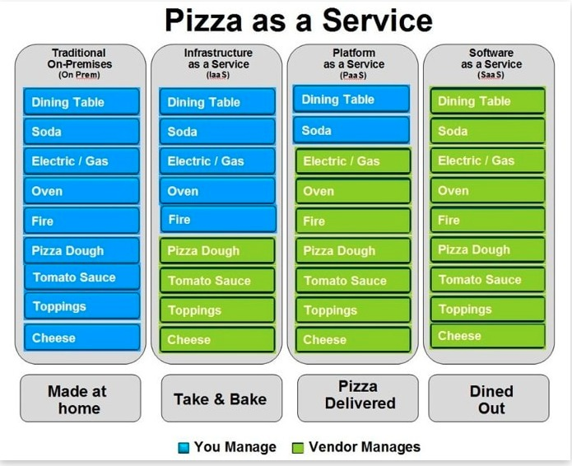

**Disadvantages of Cloud Computing:**

Although Cloud Computing provides a wonderful set of advantages, it has some drawbacks as well that often raise questions about its efficiency.

**Security issues**:

Security is the major issue in cloud computing. The cloud service providers implement the best security standards and industry certifications; however, storing data and important files on external service providers always bears a risk. AWS cloud infrastructure is designed to be the most flexible and secured cloud network. It provides scalable and highly reliable platform that enables customers to deploy applications and data quickly and securely.

**Technical issues:**

As cloud service providers offer services to number of clients each day, sometimes the system can have some serious issues leading to business processes temporarily being suspended. Additionally, if the internet connection is offline then we will not be able to access any of the applications, server, or data from the cloud.

**Not easy to switch service providers**:

Cloud service a provider promises vendors that the cloud will be flexible to use and integrate; however switching cloud services is not easy. Most organizations may find it difficult to host and integrate current cloud applications on another platform. Interoperability and support issues may arise such as applications developed on Linux platform may not work properly on Microsoft Development Framework (.Net).

**Why AWS**

**• Free tier**

**• Onthego pricing**

**• Performance**

**• Deployment speed**

**• Security**

**• Flexibility**

**AWSHISTORY**

• Amazonisinitiallyonlineretailseller.

• Awsislaunchedin 2006.

• Amazon converts the unused storage infrastructure as business“SimpleStoragewebservice”S3.

• Bytheendof2006,ElasticComputeCloud(EC2)was launched.

• TodayAWSproviding70+webservicesacross190 countries.

• Amazon Web Services (AWS)is a secure cloud services platform,offeringcomputepower,databasestorage,content deliveryandotherfunctionalitytohelpbusinessesscaleand grow.

**AWSislocatedin25geographical"regions":**

**North America (6regions)**

* USEast(NorthernVirginia),wherethemajorityofAWSserversare based
* USEast (Ohio)
* US West (Oregon)
* US West (NorthernCalifornia)
* AWS GovCloud (US),based in theNorthwestern United States, providedforU.S.governmentcustomers,complementingexisting governmentagenciesalreadyusingtheUSEastRegion
* Canada(Central)

**SouthAmerica (1region)**

* Brazil(SãoPaulo)

**Europe/Middle East/Africa (3regions)**

* EU(Ireland)
* EU(Frankfurt),Germany
* EU(London),UnitedKingdom

**Asia Pacific (6regions)**

* AsiaPacific(Tokyo),Japan
* AsiaPacific(Seoul),South Korea
* AsiaPacific(Singapore)
* AsiaPacific(Mumbai),India
* AsiaPacific(Sydney),Australia
* China (Beijing)

**Important terms which we should know before proceeding into AWS cloud.**

**Region** is adistinctgeographiclocationwhereamazonhasits infrastructure.

Alltheregionsaredesignedtobeindependentofeachother with separate power sources,internet connectivity and geographiclocation.

An **availability zone** is a separate data centres with in a region. Amazon has intentionally kept region independent of each other if one goes down it does not have effect on other.

• For e.g. Amazon have 2AZ in Mumbai ap-south-1a, ap-south-1b.

•**Edge location**s are cdn endpoints. Edge locations are used by cloud front to cache files near the user who access them.

For e.g.ifauserwantstowatchmovieit’sbettertocachethe movietolocationneartheuserforlatency.

• Amazoncloudfrontandamazonroute53areofferedatedge location.

**User can select the region depending upon following criteria.**

1. User proximity–choose the base closer to the user.

2. Cost–cost may varies based on region.

3. Compliance–lawsoflandssuchasdata protection laws willinfluenceyourchoiceofregions. 4. Serviceavailability–notallservicesareavailableina region.

* 80 Availability Zone
* 25 Geographic regions

**Why Azure**

**The following are some important aspects wherein Azure scores over AWS.**

1. **PaaS Capabilities**

Both Azure and AWS offer similar IaaS capabilities for virtual machines, networking, and storage. However, Azure provides stronger PaaS capabilities which is an important piece of Cloud infrastructure today.

Microsoft Azure PaaS provides application developers with the environment, tools, and building blocks that they need to rapidly build and deploy new cloud services. It also provides the vital 'dev-ops' connections which are important for monitoring, managing, and continually fine tuning those apps. With Azure PaaS, much of the infrastructure management is taken care of behind the scenes by Microsoft. Thus, [Azure development](https://www.saviantconsulting.com/azure-development.aspx) allows for a 100% focus on innovation.

**2.Net Compatibility**

Azure’s compatibility with the .Net programming language is one of the most useful benefits of Azure, which gives Microsoft a clear upper hand over AWS and the rest of the competitors. Azure has been built and optimized to work consistently with both old and new applications developed using the .Net programming framework. It is much easier and straightforward for enterprises to move their Windows apps to Azure Cloud as opposed to AWS or others. Thus for the several organizations that use .Net based enterprise apps, Azure is the obvious choice.

1. **Security Offerings**

Azure has been designed based on [Security Development Lifecycle](https://www.microsoft.com/en-us/sdl/) (SDL) which is an industry leading assurance process. It comprises security at its core and private data and services stay secured and protected while they are on Azure Cloud.

Microsoft was the first Cloud vendor to be approved by the European Union’s data protection authorities and the Article 29 Working Party. They were also the first to embrace the new international standard for Cloud privacy, ISO 27018. Thus, Microsoft guarantees the best in terms of safety for all operations and data on the Azure Cloud.

## Hybrid solutions for Seamless Cloud Connectivity

While Amazon is still testing the hybrid waters, Azure already has its hybrid capabilities in place. It seamlessly connects datacenters to the Cloud. Azure provides a consistent platform which facilities easy mobility between on-premises and the public Cloud.

Unlike AWS, [hybrid apps](https://azure.microsoft.com/en-in/campaigns/azure-vs-aws/) can be developed on Azure which can take advantage of the resources available within datacenters, at the service provider’s end, or within Azure itself. Azure also provides a broader range of hybrid connections including virtual private networks (VPNs), caches, content delivery networks (CDNs), and ExpressRoute connections to improve usability and performance.

## Integrated Environment

Azure brings to the table an integrated environment for developing, testing, and deploying Cloud apps. The choice of frameworks lies with the client, and open development languages further add to the flexibility for [Azure migration.](https://www.saviantconsulting.com/azure-migration-services.aspx) Additionally, readymade services like web, mobile, media in addition to APIs and templates can be leveraged to kick start Azure application development. Azure PaaS brings together all the applications, data, devices, and partners, both on-premises and in the Cloud. Its flexible toolset is ideal for solving integration needs ranging from connecting mobile apps with on-premises LOB systems, to coordinating B2B payments with partners.